**Reyes,Mj Denroe D.**

**BSIT-3H**

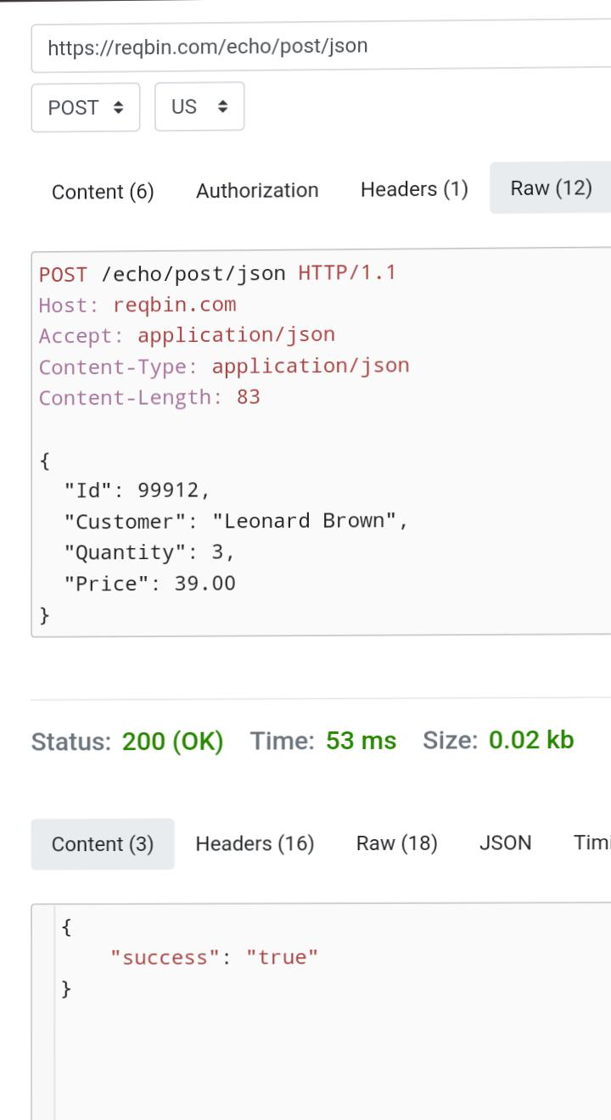**It means I was sending information about a customer named Leonard Brown, who bought an Item for $39.00. When I clicked the Send button, Reqßin sent this data to a server. After I sent the data, the server replied with a status code of 200 OK. This means the server successfully received my request and processed the data. I also saw the time it took for the request to be completed, which was around 53milliseconds. What I learned is that this whole process is called a REST API. REST APIs allow two systems. my computer and a server to talk to each other. In this scenario, my computer was sending data to the server, and the server accepted the data.**